Cloud Application Deployment & Automation Project
Cloud Platform Development (B8IS124 CA1)
Student: Michael Egburonu | Student ID: 10603840
Lecturer: Derek Mizak

1. Application Overview
This report documents the design, implementation, and deployment of a containerised Node.js web application deployed to Google Cloud Platform (GCP) using an automated CI/CD pipeline.
The primary focus of the project is on cloud deployment, automation, and orchestration, rather than complex application logic. The application serves a simple web interface and demonstrates how modern cloud platforms can be used to build, deploy, and run containerised workloads without managing underlying infrastructure.
Repository: https://github.com/mikeeggg/CloudCA1
Live URL: https://cloudca1-272999851790.europe-west1.run.app/

2. System Architecture Overview
2.1 Architecture Description
The application follows a cloud-native, container-based architecture. Source code is hosted in a GitHub repository and automatically deployed to Google Cloud whenever changes are pushed to the main branch.
Cloud Build is responsible for building the Docker image and deploying it to Cloud Run. The built container image is stored in Artifact Registry and referenced during deployment. Cloud Run executes the container and exposes the application via a public HTTPS endpoint.
This architecture removes the need to manage servers or virtual machines and enables automated, repeatable deployments.

2.2 Architecture Diagram
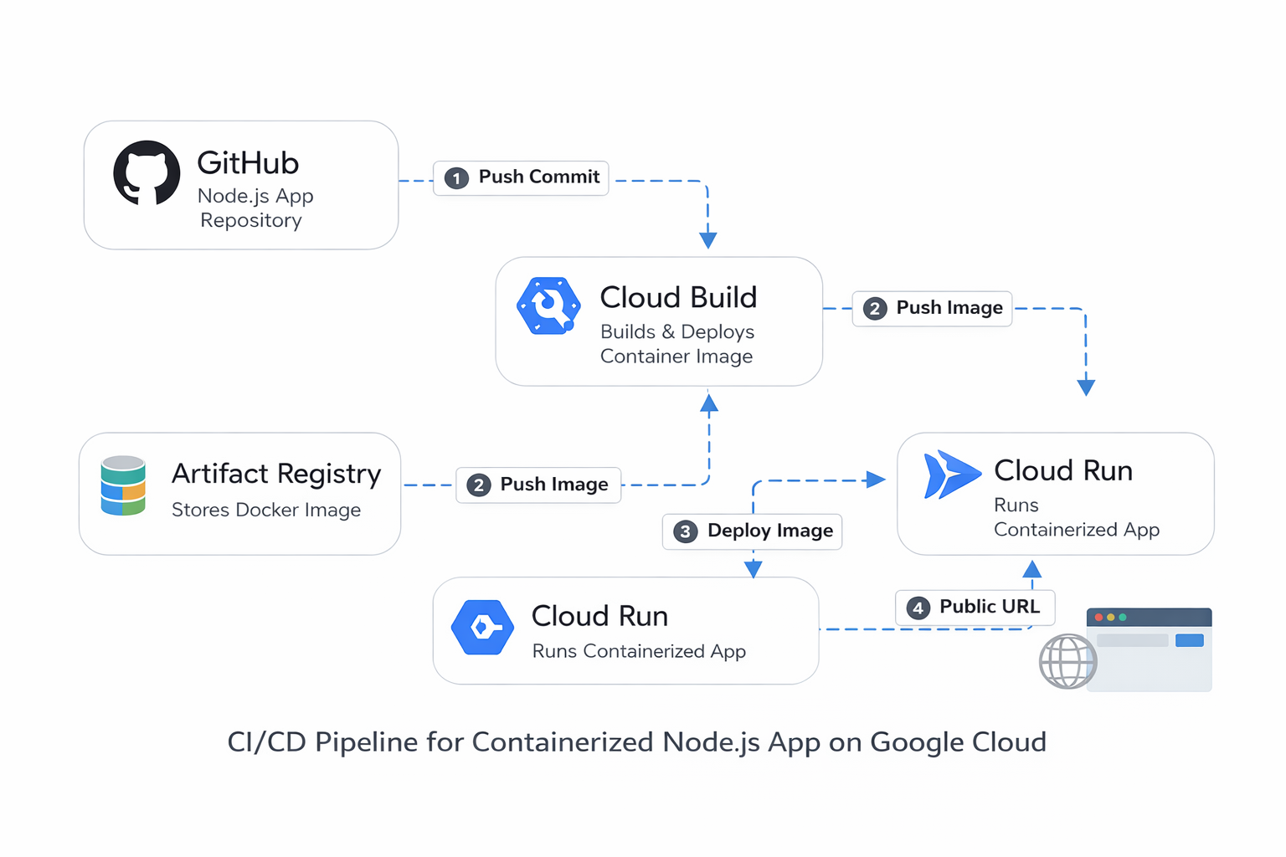
High-level architecture showing GitHub, Cloud Build, Artifact Registry, and Cloud Run.

3. Google Cloud Services Used and Justification
3.1 Cloud Run (Compute Platform)
Cloud Run is used to host the application as a fully managed, serverless container service. It was selected because it allows containerised applications to run without requiring manual server provisioning. Cloud Run also provides automatic scaling based on incoming requests and supports public HTTPS access.

3.2 Cloud Build (CI/CD)
Cloud Build provides the automated CI/CD pipeline for the project. A trigger is configured to execute on commits to the main branch of the GitHub repository. This ensures that every change is automatically built and deployed, removing the need for manual deployment steps.

3.3 Artifact Registry (Container Image Storage)
Artifact Registry is used to store Docker images generated during the build process. Each build produces a versioned image that can be traced back to a specific source commit, ensuring deployment consistency and auditability.

4. Deployment Documentation (CI/CD Pipeline)
The deployment pipeline is defined in the cloudbuild.yaml file and consists of the following steps:
- Source code is fetched from GitHub at the commit that triggered the build
- A Docker image is built using the provided Dockerfile
- The image is pushed to Artifact Registry
- Cloud Run deploys the newly built image automatically
This pipeline demonstrates a complete CI/CD workflow, ensuring that deployments are repeatable, automated, and version controlled.

5. Infrastructure Configuration
The project is fully container-based. The following configuration files are included in the repository:
- Dockerfile – Defines the container image using node:20-alpine
- cloudbuild.yaml – Defines the CI/CD pipeline
- .gitignore – Prevents unnecessary files from being committed
- README.md – Project documentation
The Cloud Run service is named cloudca1 and is deployed in the europe-west1 region within the GCP project cloud-ca1-10603840.

6. Cost Analysis
The application uses serverless and managed Google Cloud services, resulting in minimal operational cost. Under typical coursework usage, the application remains within Google Cloud free-tier limits.
Service | Pricing Model | Estimated Monthly Cost
Cloud Run | Pay per request / compute time | €0.00 – €1.00
Artifact Registry | Free tier storage | €0.00
Cloud Build | Build minutes per commit | €0.00 – €1.00
[Insert Google Cloud pricing reference screenshots here]

7. Evidence and Verification
The following evidence is provided to verify the implementation:
- Cloud Build trigger configuration and successful build history
- Docker image stored in Artifact Registry
- Active Cloud Run service
- Publicly accessible application URL
[Insert screenshots here]

8. AI Tools Usage Declaration
The following AI tools were used in accordance with permitted academic guidelines:
- ChatGPT – Assisted with structuring documentation and clarifying cloud concepts
- GitHub Copilot – Assisted with minor code completion during development
All configuration decisions, deployments, and validations were performed manually. AI-generated suggestions were reviewed and tested prior to inclusion.

9. Conclusion
This project successfully demonstrates the deployment of a containerised web application using Google Cloud Platform. Through the use of Cloud Build, Artifact Registry, and Cloud Run, the application is deployed automatically using a modern CI/CD workflow. The project highlights key cloud computing concepts including automation, containerisation, and serverless execution.

Appendix A – Google Cloud Pricing References
[Insert pricing screenshots or references here]

Appendix B – Deployment Evidence Screenshots
[Insert deployment screenshots here]

Appendix A — Evidence Screenshots (Insert)
